KA01 – Create Primary Cost Element

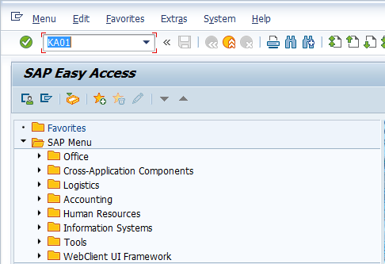

- Input KA01 in Transaction Box and press Enter key

Set Controlling Area Screen.

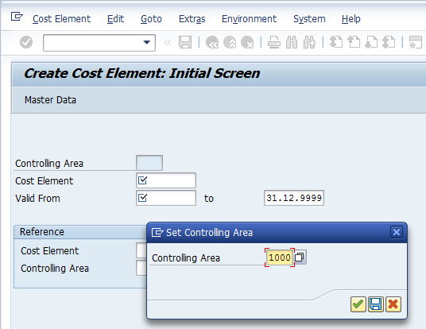

- Controlling Area: Input or select controlling area with the help of F4 key
Press Enter key

Create Cost Element Initial Screen.

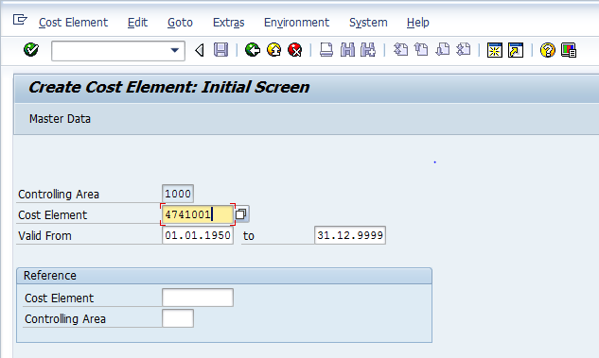

- Cost Element: Input cost element to be created
- Valid From: Input or select valid from date with the help of F4 key (i.e. cost element will be valid from this date)
- to: Input or select valid to date with the help of F4 key (i.e. cost element will be valid till this date)
Press Enter key

Create Cost Center Basic Screen.

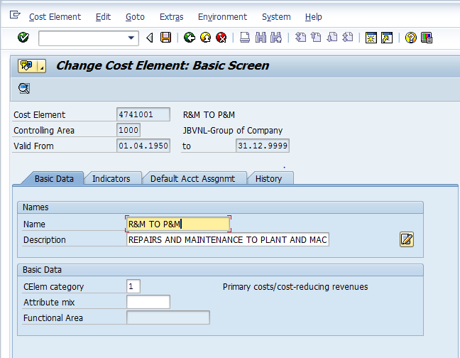

- Name: Input cost element short name
- Description: Input cost element long name
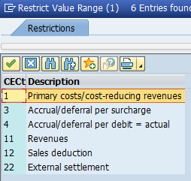
- CElem category: Select relevant cost element category from the list
Click on Save icon or press Ctrl+S keys to save the data.

The cost element has been created message appears at bottom of the screen

KA06 – Create Secondary Cost Element

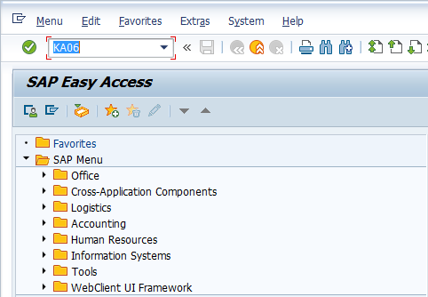

- Input KA06 in Transaction Box and press Enter key

Set Controlling Area Screen.

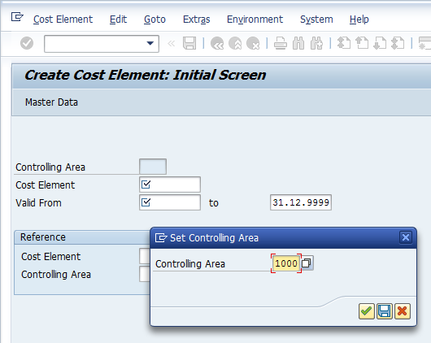

- Controlling Area: Input or select controlling area with the help of F4 key
Press Enter key

Create Cost Element Initial Screen.

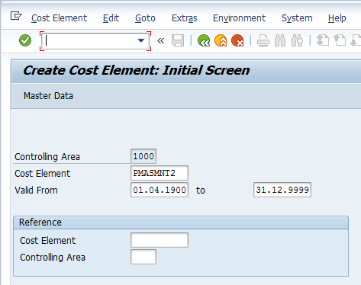

- Cost Element: Input cost element to be created
- Valid From: Input or select valid from date with the help of F4 key (i.e. cost element will be valid from this date)
- to: Input or select valid to date with the help of F4 key (i.e. cost element will be valid till this date)
Press Enter key

Create Cost Center Basic Screen.

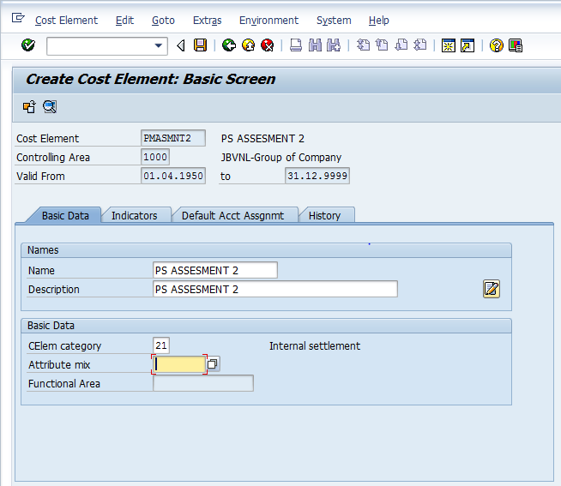

- Name: Input cost element short name
- Description: Input cost element long name
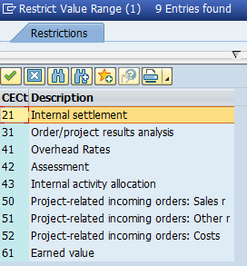
- CElem category: Select relevant cost element category from the list
Click on Save icon or press Ctrl+S keys to save the data.

The cost element has been created message appears at bottom of the screen

Manual End

